3.Create a simple cloud software application for Car Booking Reservation System using any Cloud Service Provider to demonstrate SaaS include the necessary fields such as search for cabs, from, to, rental , out station, Package type, hours/Days etc.

Step 1: Create the customer details form

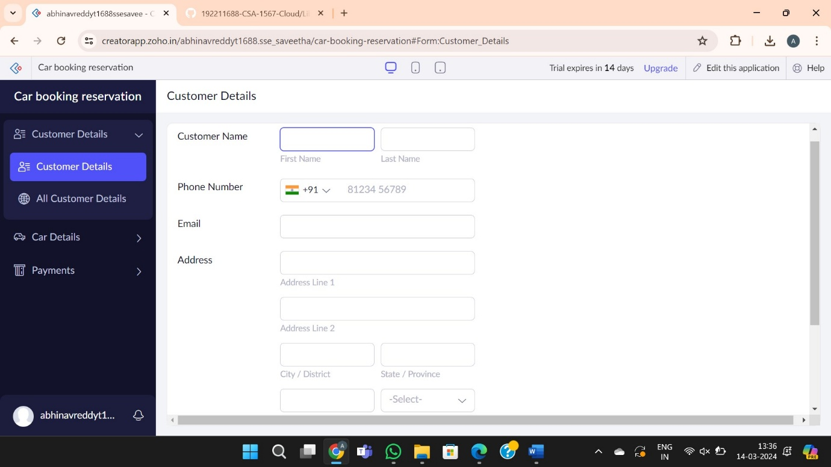

Step 2: Create the Car details form

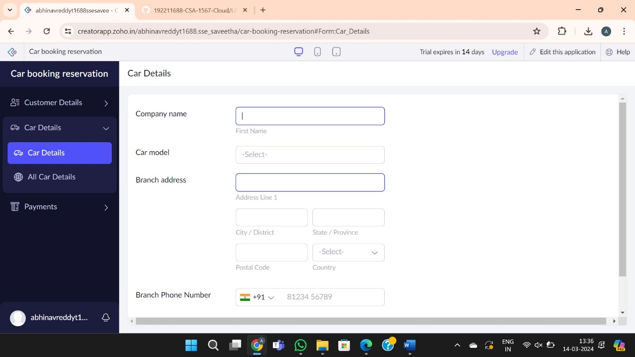

Step 3: Create the payments form

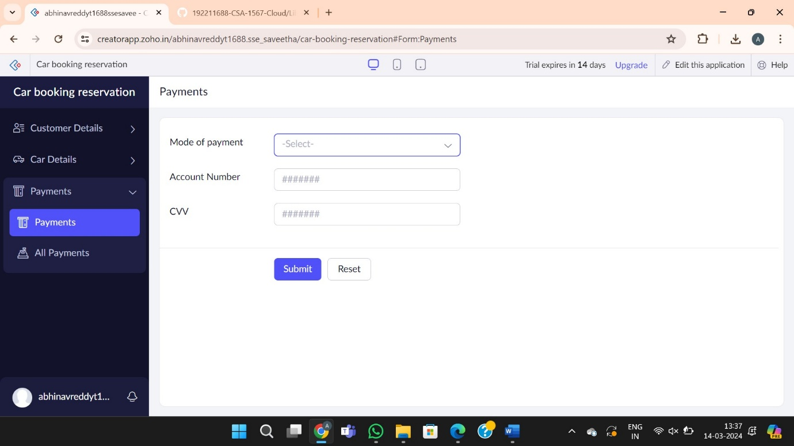

Step 4: Report the forms

